

|  |  |
| --- | --- |
| **Use Case No:** | UC01 |
| **Use Case Name:** | Download and Login |
| **Pre-Conditions** | User mobile accounts have been setup and the login details emailed to them |
| **User Story:** | I want to download the app from the mobile store, and login to view my portfolio details. |
| **MAIN SUCCESS SCENARIO:**   1. The user selects the app for download from the Play store 2. The user opens the app and enters login information | |
| **FAILED SCENARIO: UNSUCCESSFUL LOGIN**   * 1. The user is shown error message to show login information is not valid   2. The user can retry 3 times then system locks user out and displays relevant error message | |
| **FAILED SCENARIO: SERVER UNAVAILABLE / CONNECTIVITY**   * 1. The user is shown error message to show Unable to Communicate with Server | |

|  |  |
| --- | --- |
| **Req ID** | **Functional Requirement** |
| FR 1.1 | The User must be able to search for “Application” in the mobile store and select to download the app. |
| FR 1.2 | After download is complete, the user must able to select the Applications icon on the app menu.  Home screen icon to display with the Application name wrapped: Special Application  User must **open** the app, and be directed to the **Splash Screen** containing <Application> logo. The splash screen to show for 2 seconds before transitioning to the Login page.  If the user opens the app, we should check for the version and enforce upgrade if necessary. We will support current version, and the one before (n-1) |
| FR 1.3 | The user must be able to enter Username and Password and submit with the following three fields:   * **Username** (text field with hint text) – no restriction on length. Uppercase and lower case is validated. * **Password** (text field with hint text) – 8 Characters, must be a at least 3 out of 4 of – Upper/Lower/Numeric/Special characters - Standard MS Complex passwords which cannot be a permutation of the username * **Login**   Username entered to **display in text**.(exactly as entered) – truncated  Password to be **masked**. User cannot unmask.  Login Button is displayed as inactive (greyed out) while fields are not completed.  Login Button to only be “active” once Username and Login fields have been populated (minimum 1 character per field).  Keyboard selection of “done” button must trigger login automatically if user is in the **password field**.  Once user has clicked on “login” both username and password displays to remain.  Once user has been logged in, and the app is minimised, the display name for any page on the assessment must be same as that of the page the user is currently on. E.g. if the user has logged in and is in the Assessment, the display name must be Assessment.  Once logged in, the user’s login token is stored. Don’t remove the ability to authenticate offline. |
| FR 1.4 | If user tries to login with incorrect **password, username, or combanation**, show “Login Failed. Please ensure you are using the correct username and password.” Option is OK  OK returns user to the Login page with previously entered username and password **removed**. |
| FR 1.6 | The user must be shown the following error message **if there is no connectivity**:  “Failed.”  Option is OK that returns user to the Login page with previously entered username and password still there. |

1. Consider the above business requirement’s specification, what question or comments based on the quality of the requirements would you have for the Business Analyst, if any?

|  |
| --- |
| * How will the user know what it means if the system gives out an error message that reads: “Failed”, there must be an understandable error text that notifies the user where the failure is at for e.g. “Invalid Login Credentials”. * What if the User can’t find the App in google play store, are there any sites the user can go to download the App from? * How will the user know what is the cause of the error message “Unable to communicate with the server”, there must supposed to be a hint why the user is unable to communicate with the server * The name of the App is not specified on the Spec. How will the user know which App to download? * If the Login button is greyed out when the fields are not completed, “How will the user know what next to do since these no response” …. There must also be an error message appearing that notifies the User to enter **“Correct Credentials” or “Password is required” …**instead of the button being unresponsive plus these no error message appearing… * When will the user be able to login after 3 login attempts are attempted, the system has locked the User to no more login to the system because of the 3 attempts. * Will the User get a new Password after the 3 attempts has reached to login onto the application. |

1. What would you test for this project? (e.g.: 1. incorrect password 2. incorrect password validation)

|  |
| --- |
| * Software or Application Testing: The application work on Mobile devices and the Functionality is according to the Functional specification document. * Test the App if it can be used on a platform like mobile and tablets. * Will the App be accessible/can be downloaded when using different browsers like Chrome, Firefox, IE end etc. by connecting to a mobile network or wireless network like WIFI. * Test that all quality and performance guidelines are met. |

1. Which of the following defines the expected results of a test?
2. Test case specification
3. Test design specification
4. Test procedure specification
5. Test results
6. Which of the following is TRUE?
7. Confirmation testing is testing fixes to a set of defects and Regression testing is testing to establish whether any defects have been introduced as a result of changes.
8. Confirmation testing is testing to establish whether any defects have been introduced as a result of changes and Regression testing is testing fixes to a set of defects.
9. Confirmation testing and Regression testing are both testing to establish whether any defects have been introduced as a result of changes.
10. Confirmation testing and Regression testing are both testing fixes to a set of defects.
11. Consider the following Database Tables

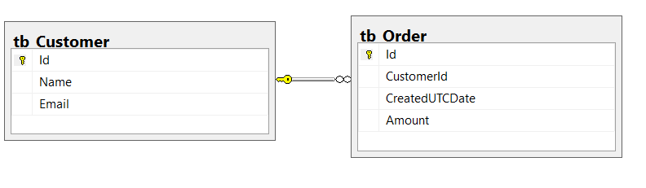

* 1. Write a SQL query to return a list of customers that have orders

|  |
| --- |
| SELECT o.CustomerId  , c.Name  , c.Email  , o.Amount  , o.CreatedUTCDate  FROM tb_Customer AS c  INNER JOIN tb_Order AS o ON o.CustomerId = c.Id |